**What is VMware ESX ?**  
ESX (Elastic Sky X) is the VMware’s enterprise server virtualization platform. In ESX, VMkernel is the virtualization kernel which is managed by a console operating system which is also called as Service console. Which is Linux based and its main purpose is it to provide a Management interface for the host and lot of management agents and other third-party software agents are installed on the service console to provide the functionalists like hardware management and monitoring of ESX hypervisor.

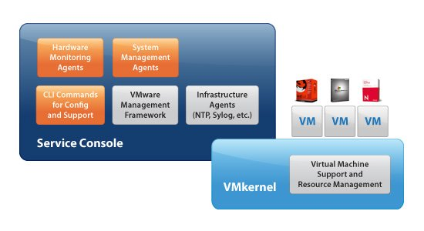

**What is VMware ESXi?**  
ESXi (Elastic sky X Integrated) is also the VMware’s enterprise server virtualization platform. In ESXi, Service console is removed. All the VMware related agents and third party agents such as management and monitoring agents can also run directly on the VMkernel. ESXi is a ultra-thin architecture which is highly reliable and its small code-base allows it to be more secure with fewer codes to patch. ESXi uses Direct Console User Interface (DCUI) instead of a service console to perform management of ESXi server. ESXi installation will happen very quickly as compared to ESX installation.

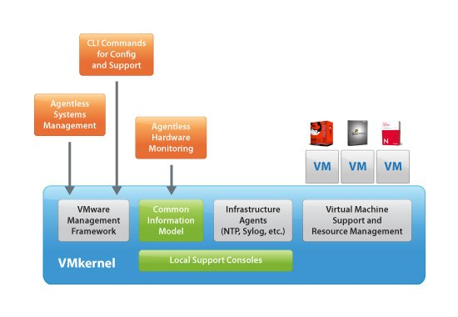

Graphics Thanks to VMware

**Difference between VMware ESX and ESXi**

 ESX 4.1 is the last version availability of ESX server. After vSphere 5, only ESXi is available.  This comparison based out of the [VMware Article](http://www.vmware.com/products/vsphere/esxi-and-esx/compare.html). Below table explains the Difference between VMware ESX and ESXi in a comparative way.

|  |  |  |
| --- | --- | --- |
| **Capability** | **ESX** | **ESXi** |
| **Service Console** | Present | Removed |
| **Troubleshooting performed via** | Service Console | ESXi Shell |
| **Active Director Authentication** | Enabled | Enabled |
| **Secure Syslog** | Not Supported | Supported |
| **Management Network** | Service Console Interface | VMKernel Interface |
| **Jumbo Frames** | Supported | Supported |
| **Hardware Montioring** | 3 rd Party agents installed in Service console | Via CIM Providers |
| **Boot from SAN** | Supported in ESX | Supported in ESXi |
| **Software patches and updates** | Needed as similar to Linux operation system | Few patches because of small footprint and more secure |
| **vSphere Web Access** | Only experimental | Full management capability via vSphere web client |
| **Locked Down Mode** | Not present | Present. Lockdown mode prevents remote users to log into the host |
| **Scripted Installtion** | Supported | Supported |
| **vMA Support** | Yes | Yes |
| **Major Administration command-line Command** | esxcfg- | esxcli |
| **Rapid deployment via Auto Deploy** | Not supported | Supported |
| **Custom Image creation** | Not supported | Supported |
| **VMkernel Network Used for** | vMotion, Fault Tolerance, Storage Connectivity | Management Network, vMotion, Fault Tolerance, Storage Connectivity, ISCSI port binding |